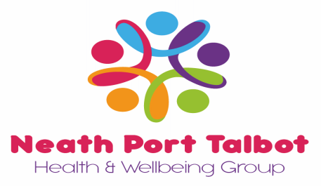

**NEATH PORT TALBOT HEALTH AND WELLBEING GROUP**

**NPTHWG**

**EXECUTIVE COMMITTEE**

**3 October 2024**

**Venue: via Microsoft Teams**

**MINUTES**

**Present:** Chair Steve Owen (SO), Huw Jones (DHJ), Anita James (AJ), Caryn Furlow-Harris (CFH), Julie Robinson (JR), Debra Lawrence (DL),

1. **Apologies:**

Lauren Margetson (LM), Andrea Joseph (ALJ), Lynne Doyle (LD), Celvin Davies (CD), Derek Jones (DJ), Shirley Freeguard (SF)

1. **Declarations of Interest**

None.

1. **Minutes of the Executive Committee Meeting – 20th June 2024**CFH had a query on item 6 regarding Data protection impact assessment.

**Action: CFH** to speak with Julia Blake regarding query and send outcome via e-mail to the committee before the next meeting.

1. **Matters Arising**All matters arising are either completed or on the Agenda for discussion.
2. **Minutes of the Finance & Governance Sub-Committee – 24th September 2024**

AJ: no update HSBC bank account, current system working well. Error with payroll and member payment for NPTHW membership. HJ confirmed this is now resolved and £8.68 has been repaid.

1. **Decisions made since last Executive Committee meeting (21.06.24 – 02.10.24)**

CFH took the group through the two decisions made since the last meeting.

1. Lucky Fridays Birthday Bonus Draw – 1 x £2,500, 5 x £500 = £5,000 – all agreed

2. Reward Gateway Renewal - £9,148 (same as last year) – all agreed

AJ said Reward Gateway have a new account manager. Going forward member savings can be shared with the group on a quarterly basis.

1. **NPTHWG – Financial Information**

HJ went through financial information circulated with the agenda and gave group an overview.

1. **Decision Required - December Bonus Draw – Proposal 5 x £1,000 = £5,000**

All in favour of decision

1. **NPTHWG – Risk Register**

Risk register circulated. No amendments or risks identified.

1. **Decision Required - Proposal to co-opt Gemma Chapple onto the Executive Committee**

**Action** for CFH to see options available and whether Gemma would have to join as a Director. To report back to group at next meeting.

1. **NPTHWG – Wellbeing Activities**

* Cinema Nights – Issue.

AJ discussed that there was a problem with member conduct at the booking desk in the Gwyn Hall for the Beetlejuice screening on the 19th of September. The Gwyn Hall requested that a member of the committee attend each event to mediate disputes. It was agreed that a form of words around member behaviour/conduct should be published on appropriate NPTHWG correspondents.

JD asked if staff involved could face disciplinary for lack of conduct.

**Action:** AJ to circulate a draft message and send to group for agreement.

* Paint Along Lady

AJ said that 50 members would be better for greater discount. Potential venues are the Princess Royal Theatre and the café at the Quays. The cost to the group would be approximately £583 for 30 members and £900 for 50 members. A £5 per head fee is to be considered.

**Action**: AJ/AJoseph to create some sort of a booking system up and running

* Adult Swimming Lessons – proposal 20% discount. All agreed.
* Margam Park – Offered discount of 10% for Luminate and Friday Nights at Margam Park. All agreed.
* Margam Park – request to offer £10 theatre discount against “Live & Let Dine at The Orangery” and “The Orangery’s Christmas Parties” (awaiting to hear if intending to offer the 10% discount as well)

1. **AOB**

CFH circulated proposal for wellbeing initiative. Will consider today but will no decision can be made as no costs included.

**Action:** Caryn to email member requesting further information.

**Next meeting: December 4th 2024, Microsoft Teams**

I hereby agree that these minutes are a true and accurate record of the meeting.

Signed (Chair) _________________ Date: ______________________

Signed (Seconder) ___________________ Date: ________________________